( Team 3 )
Project name : 9 coffe
Project idea : 9 Coffee is a calm and comfortable café designed for studying and working. The café offers a productive atmosphere with a modern and relaxing environment. It serves a wide variety of hot and cold beverages along with selected desserts and snacks to create an enjoyable experience for customers

Team members :
1 – Menna tulla Ahmed (Team leader)
2 - Hozifa ibrahim
3 – Farida Twfik
4 – Yousif Mohamed
5 – Ahmed hany
6 – Aliaa ehab
Work plan :
1 – Resarch and analysis
. Audience personas
Target Audience
- Age: 18–50 years old
- Students looking for a quiet place to study
- Freelancers needing a comfortable workspace
- Employees seeking a calm environment for meetings or focused work
- Pricing Strategy: Mid-range pricing to balance quality and affordability

2- Visual identity :
.Logo design
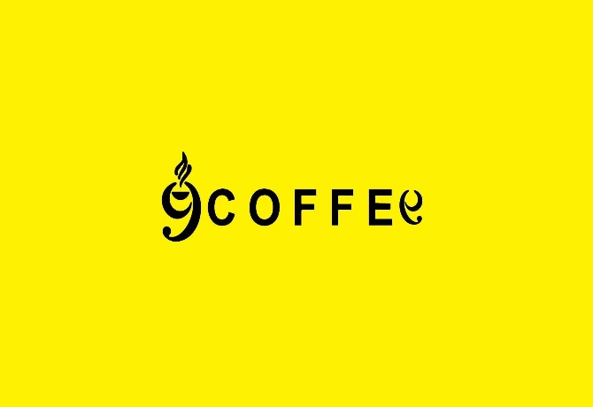
The logo is based on the text “9 Coffee” using a clean and modern typography style. The primary brand color is yellow to create a warm, energetic, and welcoming feeling. The visual identity focuses on simplicity while keeping the café recognizable and suitable for studying and working environments.

3- Main designs :
. poster
A modern café poster design that reflects focus, productivity, and comfort. The design uses yellow as the primary color with a clean layout and minimal visual elements to create an inviting atmosphere for students, freelancers, and employees.

4- Complentary products :
Menu Design – A clean and modern menu that matches the visual identity of 9 Coffee. The menu uses yellow as the main color and presents beverages and desserts in an organized and easy-to-read format.

5- Review and finalization :

The project will focus on maintaining consistency across all branding elements, ensuring that colors, typography, and visual style reflect the identity of 9 Coffee and create a unified customer experience.

6- final presentation :
Slides presentation

Links:
Facebook :
https://www.facebook.com/share/1DyQbFsPbB/

Instagrem :
https://www.instagram.com/coffeee9_?igsh=MTRwcjJtZ3g5Zm9nNA==

instructor :
DR : sameh ibrahim

